Name __________________________ Date __________ Period ____ Due _________

Regents Biology Laboratory Investigation
MITOSIS IN ALLIUM CEPA

Background Information

Allium cepa, the common garden onion which is thought to have originated in present-day Iran, seems like a strange place to go looking for science. One would think that a better place to look would be in some sort of particle accelerator, a laboratory, or even on the space station. Well, just like ogres, onions have layers, and one of those layers contains a whole lot of science.
We know that in order to complete growth, one of the eight life processes, either the size of the cells (or cell, if you’re something like an amoeba), or the number of cells must increase. Today, we’re interested in how the number of cells can increase.
Let’s say you want to make a cake. To do so, you’ll need directions. If you want a lot of people to be making a lot of cakes (like in a cake factory…mmm…), then you’ll need lots of sets of directions, one for each person. The same thing is true with cells. If you want to make another cell, you need the directions to do so, which are contained in the DNA. It follows, then, that if you wish to make many cells, you need to make sure that each cell gets an exact copy of the DNA. That is what the process of mitosis does. If a cell decides that it is time to reproduce, it uses mitosis to make sure that each new cell (which will be called daughter cells) gets an exact copy of the DNA so that it can function properly.
Mitosis is divided into phases to make it easier to understand, but in a real cell, the process is seamless. In each phase, the cell and the DNA do different various dances to prepare to become two separate cells. It is useful to know what is happening in each phase, because it will help you understand the delicate ballet of DNA that we call mitosis.

Purpose

The purpose of this lab is to help you learn how to identify the stages of mitosis, and to learn about what happens in each stage. You will also learn how to locate cells in various stages of mitosis on prepared slides. You will learn the names of the various stages of mitosis, and you will also become acquainted with the organelles and structures that make the process happen.

Materials

Prepared slides Light microscope

Procedure

INTERPHASE

This is the stage when a “cell is just being a cell.” Hanging out, talking to other cells, growing, just doing its thang. During this phase, the chromosomes are not condensed, and the DNA is draped around the nucleus in a form known as chromatin. The nucleolus is visible, as is the nuclear membrane. Most importantly, the DNA will actually make a copy of itself during this phase, in preparation for creating another cell.

1. Obtain a prepared slide from the bench. Your caring and knowledgeable teacher has laid out a fine selection from which you can choose. Thank your teacher at the earliest possible convenience. Cupcakes are a good way to say “thanks!”
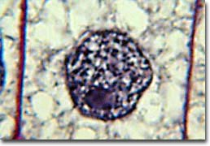
2. Locate a cell that is in interphase. Use figure 1 as a guide when you are searching.

QUESTION 1: Are chromosomes present in the nucleus of the cell that you’ve found? If not, in what form is the DNA found?

Figure 1. Onion cell in interphase.

QUESTION 2: What are the two main events that happen during interphase?

PROPHASE

In prophase, the DNA condenses to form organized structures called chromosomes. You may be able to see that each chromosome consists of two sister chromotids, which are identical copies of each other. The chromosomes are nice little packages of DNA that are easier to move around than unwound DNA in the form of chromatin. The nucleolus and nuclear membrane will start to break down. In most eukaryotes, two small organelles called centrosomes, made out of two centrioles each, will appear. Centrosomes will help pull the chromosomes apart at the appropriate moment. In vascular plants (anything with xylem and phloem, such as trees, flowers, and onions), however, centrioles are absent.

3. Locate a cell that is in prophase. Use figure 2 to guide you in your search.

QUESTION 3: Why are chromosomes formed in the cell during prophase?

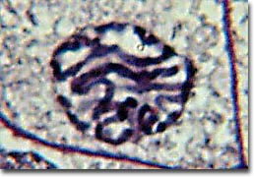
QUESTION 4: Why must the nuclear membrane break apart during mitosis?

Figure 2. Onion cell in prophase.

METAPHASE

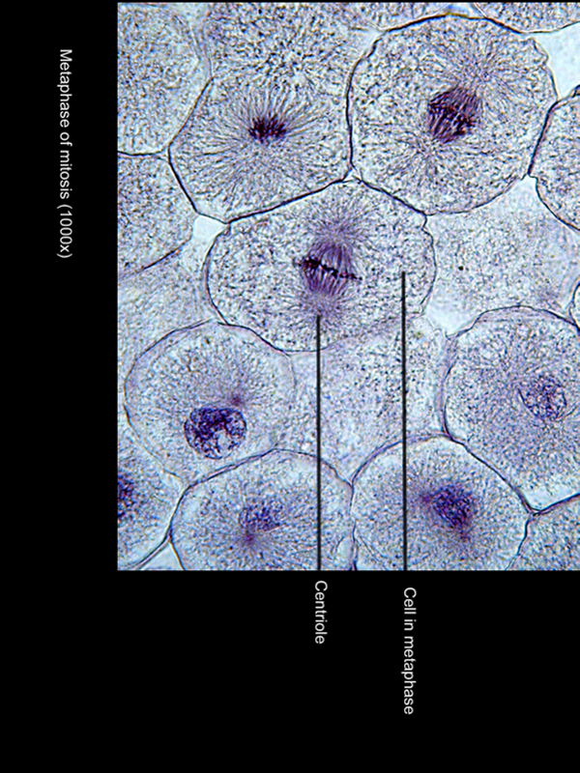
In this phase, spindle fibers made out of microtubules (which are made out of a protein called actin) attach to the chromosomes at a point known as the centromere. The centromere is made out of proteins, and is visible as a constriction around the center of the chromosome. The chromosomes are pulled by the spindle fibers, and line up on an imaginary line known as the metaphase plate.

4. Locate a cell that is in metaphase. Use figure 3 to guide you in your search.

QUESTION 5: Why must spindle fibers attach to the chromosome at the centromere?

Figure 3. Onion cell in metaphase

QUESTION 6: Some spindle fibers don’t connect to chromosomes at all. In fact, these spindle fibers grow out of opposite centrosomes and connect to each other. What do you think the purpose of these fibers is?

ANAPHASE

In anaphase, the sister chromatids of each chromosome are pulled apart. The spindle fibers that attach to the centromere are called kinetochore fibers, because the kinetochore is what they use to attach. During anaphase, these fibers shorten, pulling the chromosomes to the opposite sides of the cell. The fibers that do not attach to a chromosome are called polar fibers, and these elongate during anaphase, which pushes the two poles of the spindle further apart. The practical upshot of all this is that the sister chromatids are pulled to separate sides of the cell, and the cells becomes longer, in preparation for splitting into two new cells.

5. Locate a cell in anaphase. Use figure 4 as a guide in your search.

QUESTION 7: What would happen if a pair of sister chromatids failed to separate during anaphase?

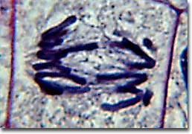
QUESTION 8: Horses have 64 chromosomes, while donkeys have 62. In some cases, a horse and a donkey can mate, and produce a mule, whose cells each have 63 chromosomes. Would having 63 chromosomes cause any problems during mitosis? Explain.
Figure 4. Onion cell in anaphase.

TELOPHASE

In telophase, the chromosomes have completely migrated to opposite sides of the cell, and they begin to de-condense back into chromatin. The nuclear envelope and nucleolus reassemble, and in plants, fungi, and bacteria, a cell plate forms. The cell plate is the beginning of a new cell wall that will eventually separate the two new cells. The spindle apparatus is disassembled, and the cells will eventually enter the next interphase. A process known as cytokinesis, or cell splitting, also starts. This is when the cytoplasm of the cell splits, and two new daughter cells are formed.
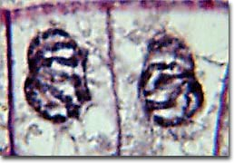
6. Locate a cell in telophase. Use figure 5 to guide you in your search.
Figure 5. Onion cell in telophase.

QUESTION 9: What would happen if a cell skipped telophase and went right onto the next interphase? Answer in terms of the number of chromosomes

QUESTION 10: If all goes according to plan, what should be different about each new daughter cell?
QUESTION 11: How many centrosomes does each new daughter cell have? How many centrioles? What does the cell need to do in order to go through mitosis again?

Analysis
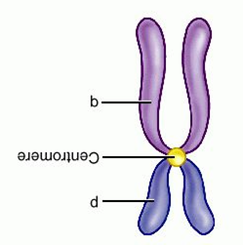
QUESTION 12: Label the chromosome shown to port. Note that the smaller arm of the chromosome is called the “p” arm for petit (small in French), and the larger arm is known as the “q” arm, simply because “q” follows “p” in the alphabet. Clever, clever scientists.

QUESTION 13: How many chromosomes are pictured in the figure to port?

QUESTION 14: How many chromatids are pictured in the figure to port?

QUESTION 15: Would a kinetochore fiber or a polar fiber attach at the centromere of the duplicated chromosome shown above?

QUESTION 16: What stage(s) of mitosis could this chromosome be in? How can you tell?

QUESTION 17: During anaphase, what is pulled apart by the kinetochore fibers?

QUESTION 18: What is true of the information on each chromatid of a duplicated chromosome?

QUESTION 19: In birds, the presence of two Z chromosomes in a zygote means that the bird becomes a male, while a Z and a W chromosome means that the bird becomes a female. In a female bird, what would the sex chromosomes be in each and every cell?

QUESTION 20: Name two things that you would change about this lab if you could.

